# CS 255 System Design Document

Kari L. Cheslock – 04/15/21

## UML Diagrams

### UML Use Case Diagram

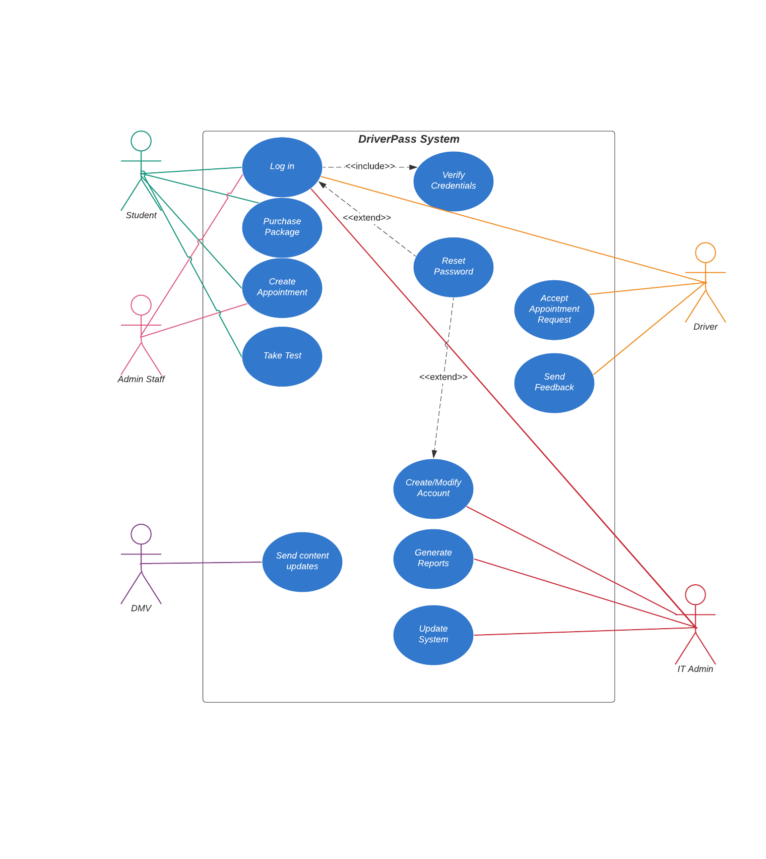

### UML Activity Diagrams

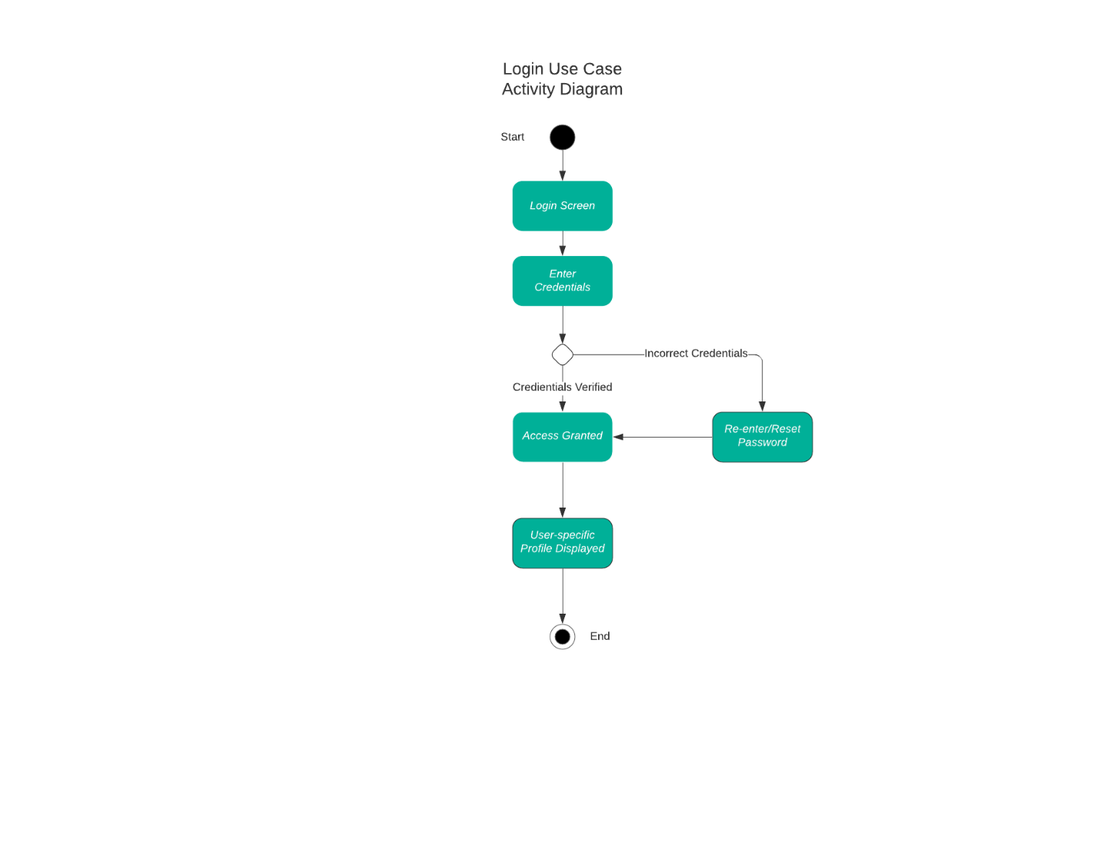

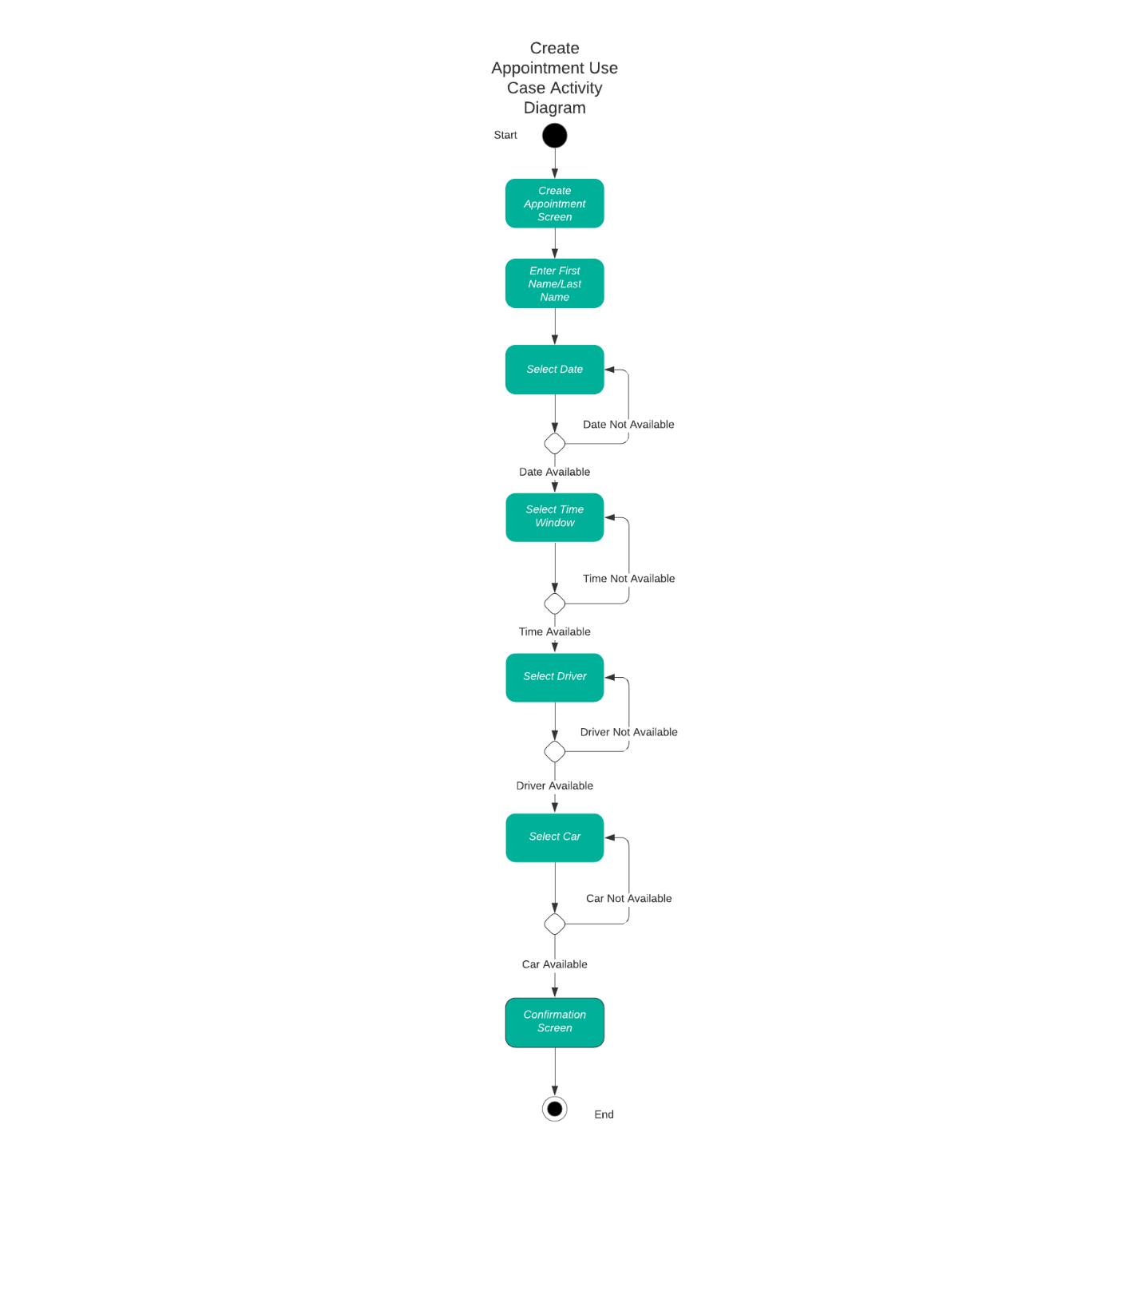

### UML Sequence Diagram

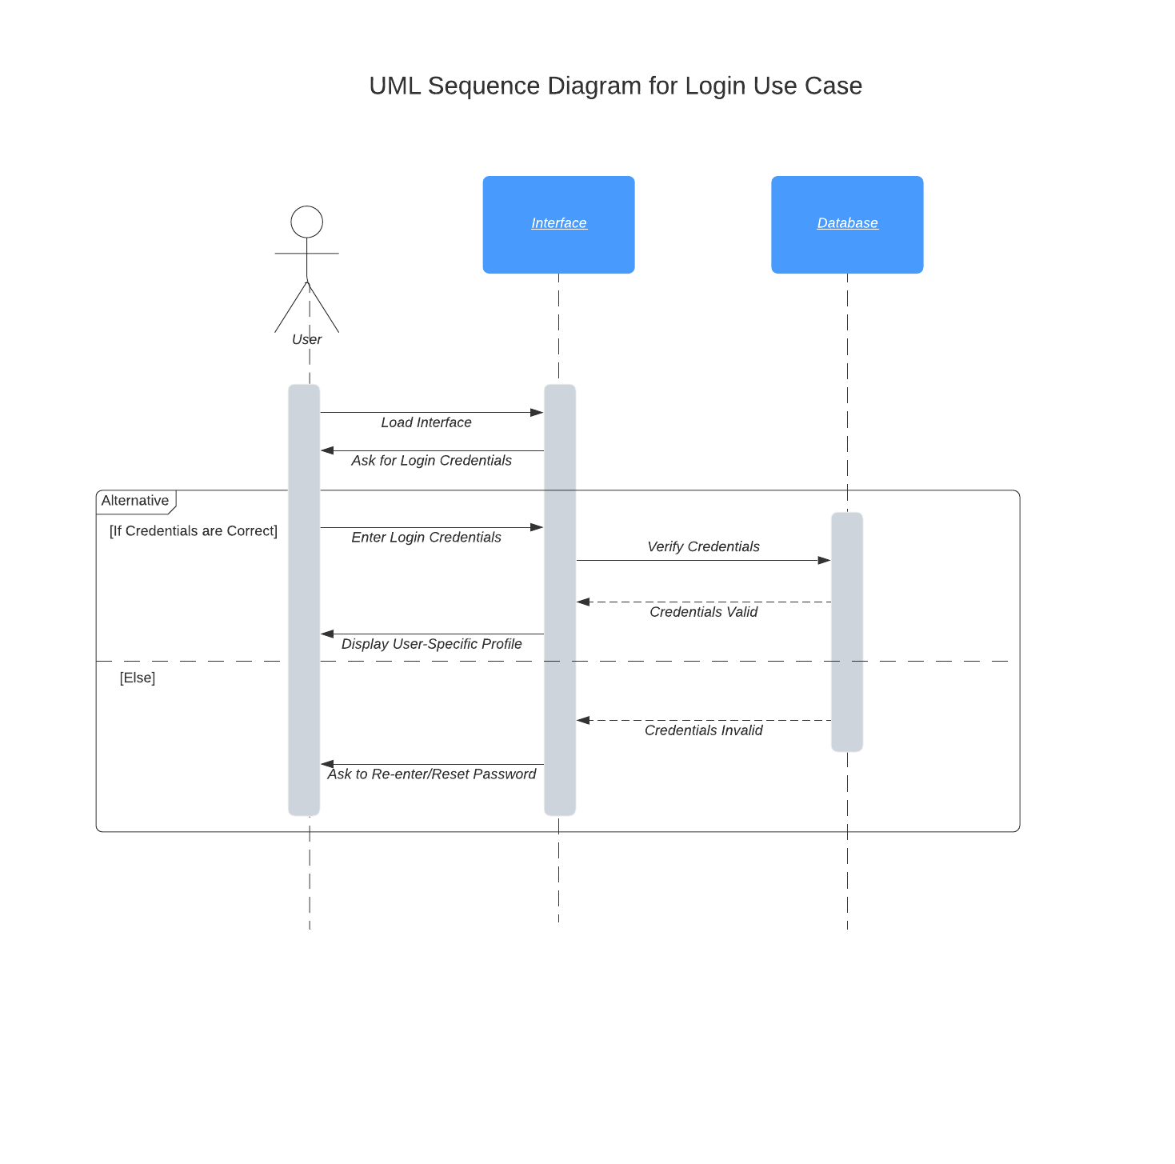

### UML Class Diagram

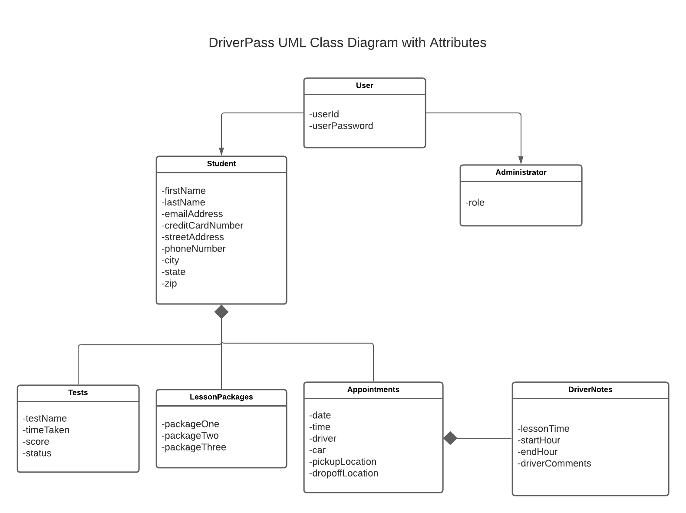

## Technical Requirements

This system will be a cloud-based web application accessible from any computer or mobile device with an internet connection. The system itself and any associated databases will reside in the cloud in order to minimize technical issues. The system will be secured through encrypted username and password credentials. Any storage space needed will be purchased through a cloud provider and will be expanded as needed. All backups for the system will also be maintained in the cloud. The system will be available 24/7 with only minimal downtown for updates which will be infrequent.